**“Innovation Management Agents in SMEs – INMA project**

**AGREEMENT NUMBER – [2015-1-TR01-KA202-022353]**

Intellectual Output 2 – “Synthesis and Analysis of the Innovation needs/challenges of European SMEs

**Elaboration of the Individual Analyses - Romania**

**SOUTH MUNTENIA REGIONAL DEVELOPMENT AGENCY**

Sigla_ADR_new

|  |  |
| --- | --- |
| sigla4 | This project has been funded with support from the European Commission. This publication reflects the views only of the author and the Commission cannot be held responsible for any use which may be made of the information contained therein. |

**COUNTRY REPORT:**

**INNOVATION AND NEW TECHNOLOGIES IN SMES / HHRR**

# INTRODUCTION

**South Muntenia Regional Development Agency (SMRDA)** has been established in 1999 on the basis of the Law no. 151 /1998 on regional development in Romania (updated later by Law no.315.2204), as a non-governmental agency, non-profit and of public utility.

Its mission is to develop and implement regional policies and programmes that lead towards the alleviation of economic and social imbalances across the region and contribute to a further sustainable and balanced development.

The main fields aimed by the regional policies and programs are fostering the entrepreneurship and innovation, balancing the labor market, stimulating the technology transfer, attracting inward investment, development of SMEs, improvement of infrastructure, etc. In this regard, the Agency

identifies and develops projects of local and regional interest as well as projects of intraregional cooperation. With the support of the Regional Development Board, the Agency actively promotes the region and fosters inward investment attraction and export, develops partnerships with similar bodies and institutions from the European Union and participates in international projects.

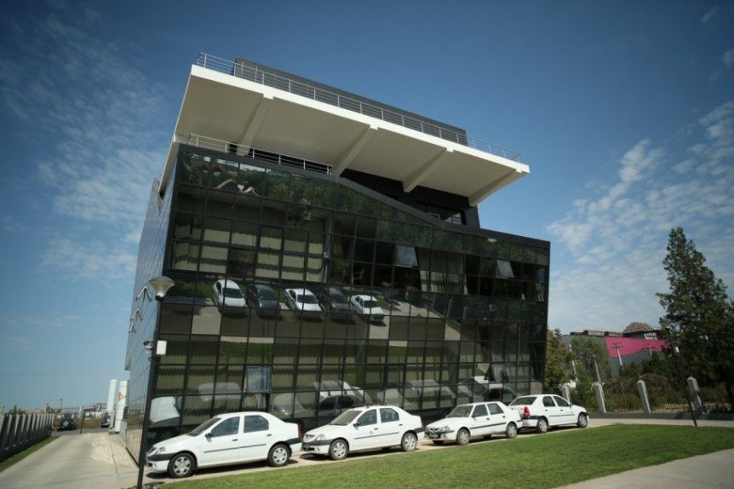

South Muntenia Regional Development Agency is actively involved in all the phases of the regional development (programming, implementing, monitoring and evaluation). To that respect, the Agency has designed the Regional Development Plans for the 2004-2006, 2007-2013 and 2014-2020 programming periods, also feeding into the Regional Operational Programme 2007-2013 and Regional Operational Programme 2014 - 2020. Also, in close cooperation with the Minister for Economy and the Regional Chamber of Commerce, it has prepared the Regional Export Strategy 2006 – 2009 and participated to the design of the National Export Strategies for 2006 – 2009 and 2010 – 2013. Starting with 2007, part of the Agency is acting as Intermmediate Body for the Regional Operational Programme 2007-2013 and Regional Operational Programme 2014 – 2020 and it is evaluating the impact achieved through the implementation of projects within the region.

In the same time, the Agency is committed to embedding a culture of innovation within the region. This is reflected in the Innovating South Muntenia project, financed by the European Commission under the 6th Framework Programme – Regional Innovation Strategies, implemented during 2005-2008. The strategic objective of the RIS InnSoM was to enhance the competitiveness of South Muntenia by preparing a sound Regional Innovation Strategy for South Muntenia Region, in order to enhance its sustainable development in the context of the new knowledge-based economy, by promoting innovation as a regional policy. The result of InnSoM Project, South Muntenia RIS is one that fosters mostly investment in people and ideas and values endogenous entrepreneurship.

Within the Regional Innovation Strategy of South Muntenia 2008-2013, the process of reversing the brain drain was a theme in-depth investigated through the Analysis of the Regional Innovation Support System. In recent years, more than ever, the region is confronting with a serious phenomenon of brain drain, due both to its location (is surrounding Bucharest – the capital of Romania) and to the economic decline.

## General Context:

**Brief description of the country and region (size, population, socio economic structure, etc)**

***Geography and demography***

With an area of 238,400 square kilometers, Romania is the twelfth largest country in Europe. Located at the intersection of Central and Southeastern Europe, bordering on the Black Sea, the country is halfway between the equator and the North Pole and equidistant from the westernmost part of Europe—the Atlantic Coast—and the most easterly—the Ural Mountains. Romania has 3,195 kilometers of border. Republic of Moldova lies to the east, Bulgaria lies to the south, and Serbia and Hungary to the west. In the southeast, 245 kilometers of sea coastline provide an important outlet to the Mediterranean Sea and the Atlantic Ocean.

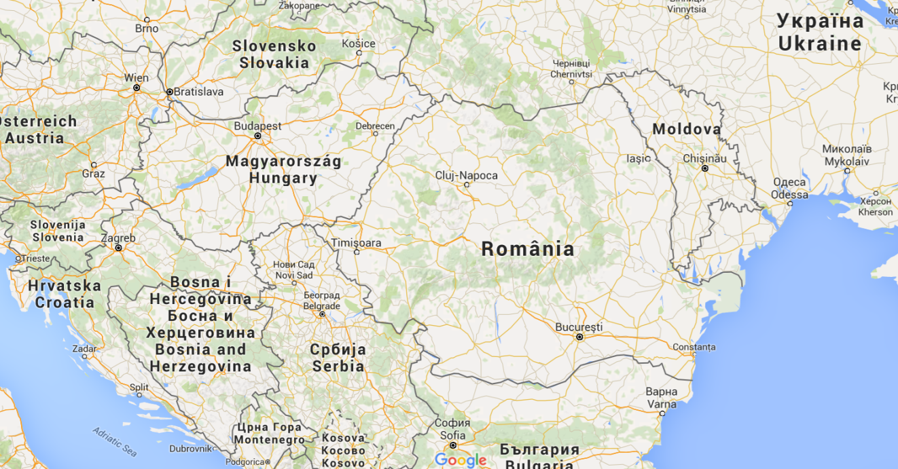

About 89.4% of the people of Romania are ethnic Romanians, whose language, Romanian, is an Eastern Romance language, descended primarily from Latin with some Bulgarian, Serbian, German, Greek, Hungarian and Turkish borrowings. Romanians are by far the most numerous group of speakers of an Eastern Romance language today. It has been said that they constitute an island of Latinity in Eastern Europe, surrounded on all sides either by Slavic peoples or by the Hungarians.The Hungarian minority in Romania constitutes the country's largest minority, 6.5 % of the population.

**Brief description of the South Muntenia region**

The South Muntenia region is the second most inhabited region in Romania, having a population of over 3.2 million inhabitants, that represents 15% of the national population. From the point of view of the demographic evolution, the trend is descending, the population decreasing with 13,000 people per year in average. South Muntenia is the region from Romania with the highest number of inhabitants in the rural environment (57% of residents).

**Evolution of the population of South Muntenia Region, Trend in 2008 – 2015**

Source: National Institute of Statistics, Romania

South Muntenia region is located in the South-East of Romania, has a surface of 34,453km2 (14.45% of the country) and it is composed from 7 counties (Arges, Calarasi, Dambovita, Giurgiu, Ialomita, Prahova, Teleorman), 16 municipalities, 32 towns, 519 communes and 2019 villages. It is the third largest region in Romania, after the North East and South East.

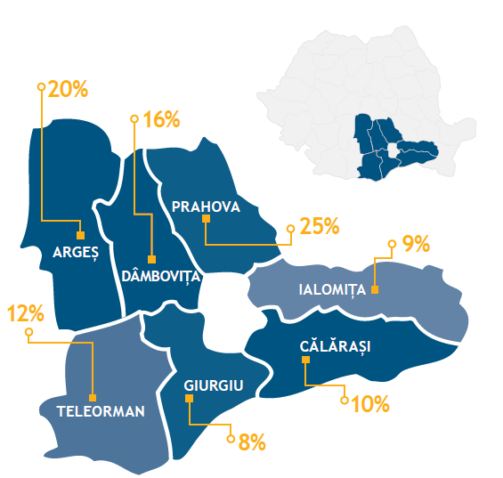

Source: Smart Specialization Strategy of South Muntenia Region

From the geographical characteristics and socio-economical structure point of view, South Muntenia region can be split into 2 distinctive areas. The Northern part (consisting of Arges, Dambovita and Prahova counties) is highly developed from many aspects, concentrating a high number of new or traditional industrial companies. It is in the Northern part where are located all 4 universities and the vast majority of research institutes, in direct connection with the predominant industries: chemical and petrochemical, metallurgy, automotive, construction, food processing, and information technology.

The Southern part (meaning Teleorman, Giurgiu, Calarasi and Ialomita counties) is located in the Romanian Plain and it is less developed, agriculture being the predominant sector. The poor level of

development of the Southern part is mainly due to the fact that this area has been in time the target of an artificial industrial development. As a consequence, starting with 1990s it has been affected by the transition to the market economy by closing and restructuring the activity of the state owned companies.

In the same time, the region has an important touristic potential for development of tourism and the recreative activities, due to the favorable natural conditions and to the existing cultural and historical heritage. The main touristic attractions for winter sports and weekend tourism are located in the Northern part - the mountain resorts from Prahova Valley – Bucegi Mountain that can meet the accommodation needs and have a proper infrastructure. In 2015 South Muntenia region had 9.11% from the accommodation capacity in function (fifth rank at national level).

A distinguishing feature, with multiple socio-economic implication is that, South Muntenia is the only region in the country that contains an enclave in the middle region, namely Bucharest - Ilfov region. Another important aspect of the major influences in the development of the region is the presence in the south of the region of the Danube River.

***Socio Economic Structure***

In the last 20 years, Romania has made considerable progress developing institutions compatible with a market economy. Joining the European Union (EU) in 2007 was a driving force for reform and modernization. When the global financial crisis hit in 2008 - 2009, Romania made a quick recovery thanks to prudent macroeconomic management. The crisis prompted long-needed reforms, with support from the international financial institutions, in health, education, the financial sector, public financial management, public administration, social insurance, and social assistance. Some of these reforms address short-term responses to the crisis, while others are anchored in a coherent longer-term strategy.

[Romania](https://en.wikipedia.org/wiki/Romania) has a developing, upper-middle income [market economy](https://en.wikipedia.org/wiki/Market_economy), the 17th largest in the [European Union](https://en.wikipedia.org/wiki/European_Union) by total nominal GDP and the 13th largest based on [purchasing power parity](https://en.wikipedia.org/wiki/Purchasing_power_parity). Until 2009, Romanian economic growth was among the fastest in Europe (officially 8.4% in 2008 and more than three times the EU average). The country is a regional leader in multiple fields, such as [IT](https://en.wikipedia.org/wiki/Information_technology) and [motor vehicle production](https://en.wikipedia.org/wiki/List_of_countries_by_motor_vehicle_production). [Bucharest](https://en.wikipedia.org/wiki/Bucharest), the capital city, is one of the largest financial and industrial centres in Eastern Europe

During the period 2009 - 2013, Romania's GDP grew by 3.5% compared to the previous period. The year 2013 is the third consecutive year of growth and the growth rate registered in 2013 (31.895,4 lei/people) is the highest rate recorded by Romanian economy in the last five years. It has to be mentioned that the increase of 3.5% of GDP in 2013 places Romania on the first place among EU member states, the EU average being 1.0%.

Althought in 2013, South Muntenia region contributed with only 1.10% to the achievement of Romanian GDP, at the regional level, Arges and Prahova counties detaches from the other ones contributing together to achieve 55.36% of regional GDP. This is mainly due to the concentration of the most important companies in the automotive and petrochemical industries in these two counties (Dacia-Renault, Arpechim, Petrobrazi, Petrotel-Lukoil). At the opposite pole are the Southern counties of the region due to the mainly agrarian character that contributes to the lowest percentage of regional GDP achievement.

In the third quarter of 2015 the GDP growth was surprisingly strong given the significant drop in agricultural production. The expansion was driven mainly by services, with retail trade surging after the cut in the VAT for food as of 2015 June 1st, and by the ICT sector.

Even if, the employment and activity rates shows signs of improvement during the period 2013 – 2015, Romania continue to be among the lowest in the EU. The employment rate for the 20 - 64 age group stagnated in 2013, increased to 62.6 % in the third quarter of 2014 and also with 63.20% in the same period of the next year.

**The evolution of the employees during the period 2013 - 2016**

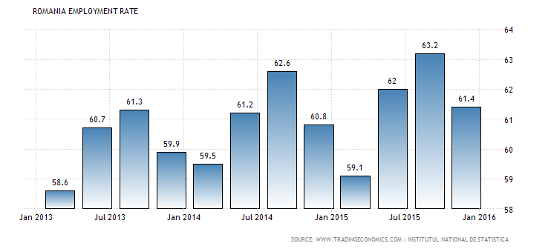

It was noticed that, in the third quarter of 2015 the GDP growth was surprisingly strong given the significant drop in agricultural production. The expansion was driven mainly by services, with retail trade surging after the cut in the VAT for food as of 2015 June 1st, and by the ICT sector.

On the other hand, foreign direct investment went up by 18% in the first five months of 2015 compared to the same period of last year, reaching EUR 1.29 billion, out of which EUR 650 million were capital increases and EUR 637 million were net intragroup loans,, according to National bank of Romania. Moreover, last year, foreign direct investment in Romania went down by about 11% compared to 2013, to EUR 2.43 billion. In 2013, the FDI had grown by 27%, reaching a post-crisis high of EUR 2.71 billion. Also, the highest FDI level was recorded in 2008, when EUR 9.5 billion entered the country

**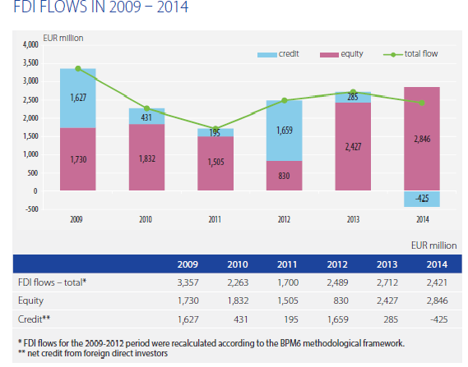**

Source: Foreign Direct Investment in Romania 2014 – National Bank of Romania

Moreover, the table below highlights the developments in the FDI enterprises’ turnover and the

average annual number of employees in these enterprises in 2009 – 2014.

|  |  |  |
| --- | --- | --- |
| **Year** | **Turnover**  **-EUR million -** | **Average number of employees**  **(thousands persons)** |
| **2009** | **109.907** | **1.084** |
| **2010** | **112.851** | **1.055** |
| **2011** | **132.309** | **1.075** |
| **2012** | **125.473** | **1.102** |
| **2013** | **129.615** | **1.083** |
| **2014** | **131.820** | **1.124** |

Source: Foreign Direct Investment in Romania 2014 – National Bank of Romania

**FDI net flow and its components by enterprises activity**

|  |  |  |  |  |  |  |  |  |
| --- | --- | --- | --- | --- | --- | --- | --- | --- |
| **ECONOMIC ACTIVITY** | **FDI Net Flow** | | | | | | | |
|  | **Equity** | | | | | | **Net credit** |
|  | **Equity participation** | **Reinvested earning (+) /Net loss (-)** | | | |
| **Total of which** | **Profit** | **Loss** | **Dividents** |
| **0** | **1=2+8** | **2=3+4** | **3** | **4=5-6-7** | **5** | **6** | **7** | **8** |
| **Industry of which:** | **980** | **1.309** | **1.686** | **-377** | **2.548** | **1.786** | **1.139** | **-392** |
| **Mining** | **4** | **- 49** | **140** | **-189** | **270** | **249** | **210** | **53** |
| **Manufacturing of which:**  **- food beverages of tabacco**  **- cement, glassware,ceramics**  **- wood products, including furniture**  **- manufactures of computers,electroni, optical, and electronic products**  **- machinery and equipment**  **- metallurgy**  **- transport means**  **- oil proccesing, chimicals, rubber and plastic products**  **- textiles, wearing apparel and leather goods**  **- others manufacturing sub-sectors**  **Electricity, natural gas and fishing**  **Professional, scientific, technical and administrative activities and support services**  **Agriculture, forestry and fishing**  **Trade**  **Construction and real estate transactions**  **Hotels and restaurants**  **Financial intermediation and insurance**  **Information technology and communications**  **Transportation**  **Other**  **TOTAL** | **-6** | **4** | **150** | **-146** | **141** | **181** | **106** | **-10** |
| **-54** | **10** | **21** | **-11** | **94** | **43** | **62** | **-64** |
| **124** | **89** | **39** | **50** | **169** | **57** | **62** | **35** |
| **168** | **160** | **77** | **83** | **163** | **35** | **45** | **8** |
| **111** | **178** | **76** | **102** | **161** | **35** | **24** | **-67** |
|  |  |  |  |  |  |  |  |
| **158** | **96** | **117** | **-21** | **256** | **236** | **41** | **62** |
| **411** | **229** | **76** | **153** | **454** | **141** | **160** | **182** |
| **-106** | **219** | **437** | **-218** | **399** | **316** | **301** | **-325** |
| **77** | **71** | **1** | **70** | **127** | **19** | **38** | **6** |
| **46** | **46** | **18** | **28** | **56** | **12** | **16** | **0** |
| **47** | **256** | **534** | **-278** | **258** | **462** | **74** | **-209** |
| **24** | **32** | **93** | **-61** | **306** | **248** | **119** | **-8** |
| **62** | **86** | **10** | **75** | **121** | **41** | **5** | **-23** |
| **225** | **549** | **430** | **119** | **976** | **369** | **458** | **-374** |
| **646** | **626** | **542** | **84** | **497** | **317** | **96** | **20** |
| **108** | **-3** | **-2** | **-1** | **28** | **22** | **7** | **111** |
| **22** | **73** | **1.367** | **-1.294** | **529** | **1.669** | **154** | **-51** |
| **253** | **115** | **46** | **69** | **325** | **153** | **103** | **138** |
| **92** | **93** | **45** | **48** | **123** | **46** | **29** | **-1** |
| **9** | **-33** | **5** | **-38** | **65** | **67** | **36** | **42** |
| **2.421** | **2.846** | **4.222** | **-1.376** | **5.518** | **4.718** | **2.176** | **-425** |

Source: Foreign Direct Investment in Romania 2014 – National Bank of Romania

***South Muntenia region* ‘s economy**

During the period 2004 – 2014 the South Muntenia region was characterized by a slightly upward trend, influenced mostly by the economic crisis, reflected in the values of the main indicators of the economic growth evaluation. An important issue which is highligted by the economic analysis of South Muntenia is related to bring together all seven counties from which three counties from the north of the region (Arges, Dambovita and Prahova), are the most important actors in the development of the industrial sector and the other four counties in the south of the region – Calarasi, Giurgiu, Ialomita and Teleorman – with tradition, mainly, in agriculture and agro-food.

The region is situated on the second place at national level after Bucharest – Ilfov, because more than 56,758 active local units in South Muntenia region have reached over 7,53 % of the turnover in 2014, obtained by the local units existing at national level. From the point of view of net investments performed, with over 4.194 billion RON, South Muntenia region also occupies the second place in the ranking of regions in Romania at this chapter.

|  |  |  |  |  |
| --- | --- | --- | --- | --- |
|  | **TURNOVER**  **-million RON-** | **EMPLOYED PERSONS**  **-people/thousand-** | **LOCAL UNITS**  **-number -** | **NET INVESTMENT**  **-billions -** |
| **South Muntenia** | **83,026** | **1,236.3** | **56,758** | **4,194** |
| **Romania** | **1,102,959** | **8,910** | **521,381** | **60,198** |
| **WEIGHT** | **7,53%** | **13.88%** | **10.89%** | **6.97%** |

Source: National Institute of Statistics, Romania, Own calculation

South Muntenia region is an important foreign direct investment (FDI) attractor, approximately 7% of the national FDI inflow in 2014, although dropping one positions since 2011 as investments started to be directed more towards the West and Centre region of Romania. FDI was channeled mainly to the automotive and petrochemical industries.

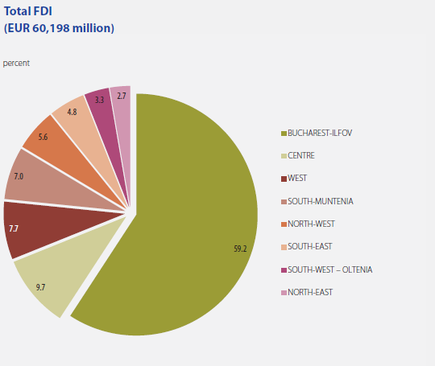

Source: Foreign Direct Investment in Romania in 2014- Romanian National Bank

The main sectors that contributed in 2014 to the regional GDP in South Muntenia were highlighted in the table below ( Industry- with a share of 12.47%, beeing followed by Commerce with a share of 3,45%);

|  |  |  |  |  |
| --- | --- | --- | --- | --- |
| **South Muntenia Region** | | **TURNOVER**  **-million ron -** | **EMPLOYED PERSONS**  **-people/thousand-** | **LOCAL UNITS**  **-number -** |
| **1** | **Agriculture** | **13,753** | **404.4** | **3,131** |
| **2** | **Industry** | **137,503** | **257.3** | **5,516** |
| **3** | **Commerce** | **38,034** | **142** | **22,301** |
| **4** | **Services** | **676** | **171.6** | **15,744** |
| **TOTAL** | | **189,966** | **975.30** | **46,692** |

Source: National Institute of Statistics, Romania, Own calculation

**Brief description of main characteristics of SMEs and their investment in innovation and new technologies in the country and region**

In the last 50 years, micro, small and medium-sized enterprises (SMEs) have became valuable actors in the economies of the world, in terms of created jobs and their direct contribution to raising the living standards of the communities in which they operate. Due to their small size, SMEs enhance the market’s atomicity, diminishing the power of big business to influence it. In addition, their large numbers fosters competition by limiting the monopoly position of big firms and thus reducing their ability to raise prices. Moreover their capability to respond quickly to local needs because of their production flexibility makes them more efficient in local markets than their larger counterparts.

Sustaining SME’s is a top priority for the European Commission. Some priorities are improving access to finance, helping SMEs to go abroad, ensuring fair competition, education and skills for entrepreneurship, environmental challenges, SMEs’ research and innovation, support for SMEs at regional level. In the context of global crisis SME’s across Europe are facing various and important problems.

European Union recognizes and appreciates the importance of SME sector as a base for the modern economic development. This sort of enterprises has the ability to respond in a flexible mode on competitive and strong markets and to adapt rapidly to the structural changes of the global economy. A strong SME sector can sustain stability and macroeconomic growth.

In Romania as well as in other EU countries SME’s are approximately 90 % of all the enterprises and they represent the main drivers in obtaining employment and GDP. A SME has the ability to react in a more flexible mode on markets which are competitive and strong and to adapt rapidly to the structural changes of the global economy.

The main problem that this type of enterprises is facing is the decrees of internal demand. The global economic and financial crisis affected many of the small and medium company’s strategies. More than half of these are expecting to have financial results inferior to the year 2009. National Council of Private SME indicates that the number of those with inferior financial result raised 8,3 times compared with the same period in the last year having direct impact on this year’s GDP.

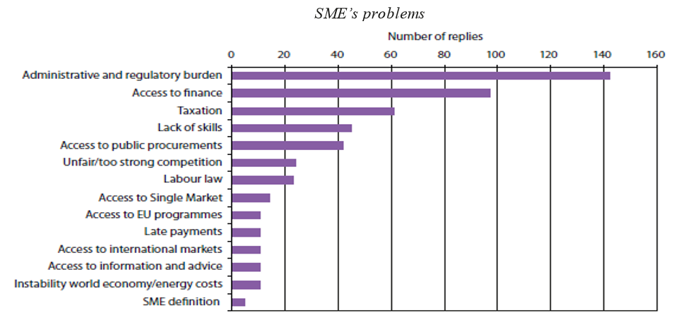

Source: The Importance of SME’s in Romania, in the context of the global crisis

The SMEs predominate in the Romanian economy having a substantial contribution to the GDP (70% in 2014) and playing a main role in job creation. Thus, in 2014 in the SMEs sector were employed 60.7% of active population and the weight of turnover achieved by these firms were of 57.6% from the total firms.

The number of SMEs register a positive evolution: in 2014 there were active about 519,602 of SMEs, which means an increase of 12% in comparison with the year 2011.

In 2013, there were 497,036 SMEs, from the total of 498,768 private firms (96%) and in 2014, there was registered and increase with 4,34% of the number of Romanian SMEs. The capital of Romania, Bucharest alone represents approximately 25% of the total of companies listed with a number of 126.554 companies, followed by Cluj with 5.35% with a number of 27,153 companies and Constanta with 4.11 % with 20,816 companies.

In structure, the micro–enterprises dominate the SME sector (88%) while the small firms represents 10% and the medium firms represents 2%, in 2014. But there are some differences in function of the activity sector, for instance in industry and constructions sectors, the microenterprises represents 74.9% in comparison with trade and other services, where they represent 92.2% . Also, the weight of medium firms in industry and constructions represents 17.2% while in the sector or trade and other services it represents 6.7% in 2014.

Meanwhile, 12 % of the total SME’s from Romania are registered in the South Muntenia region, Prahova County and Arges County together holds 55,34% of the total number of SME’s. It was noticed that the total number of micro enterprises (with 9 or less employees) is 49,347 and it represents over 87% of the enterprises from this region. An estimated number of 39 % of South Muntenia region’s companies activate in the field of commerce.

At national level, the number of new companies increased significantly in 2015 compared to 2014 from 56,381 enterprises to 64,417 enterprises. Also, the number of enterprises which were dissolved increased in 2015 with 19 % from the previous year.

**Registered/Dissolved SMEs in the South Muntenia Region**

Source: National Trade Register Office from Romania, Own calculation

At regional level, in 2015, in South Muntenia region were registered 6,533 enterprises with a growth of 13,5 % from the previous year. Also, 11% of the total number of the dissolved companies at the national level, are located in the South Muntenia region and increased by 4.8% in 2015 compared to 2014.

The role of innovations for SMEs has been acknowledged, as surviving by maintaining or increasing market share through innovation is seen as a major issue for all SMEs. So, in 2014, from the point of view of innovation expenses, Romania spent over 2.555.000 million RON and it had engaged in this activity 42.963 employees. Moreover, with 296 million RON, South Muntenia region occupies the second place in the ranking of regions, after Bucharest-Ilfov in 2014. Having in regard that the research-development activity involved 3,826 employees in 2014, the region is only outrun by Bucharest-Ilfov region with a number of 20,212 employees.

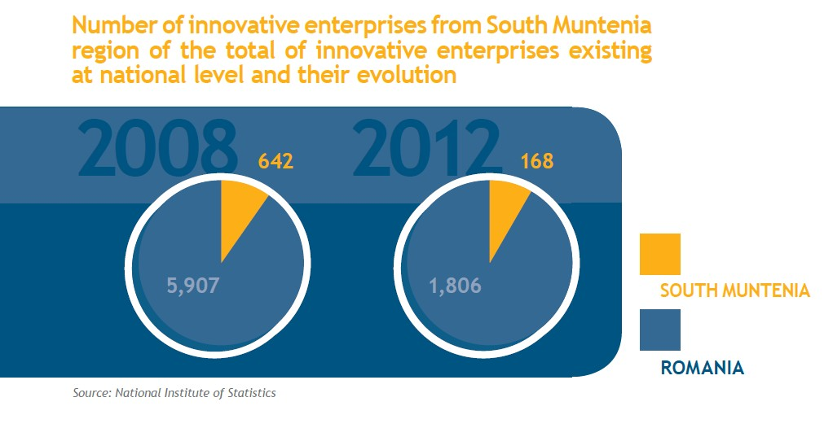Source: Smart Specialization Strategy of the South Muntenia Region

The trend of the number of innovative enterprises, both at national as well as regional level is a descending one. If in 2008, there were 642 such units operating in South Muntenia region, in 2012, their number decreased to 168, value representing less than 27%. The trend is maintained at national level as well, where out of almost 6,000 existing units in 2008, in 2012 there were only 1,806 left.

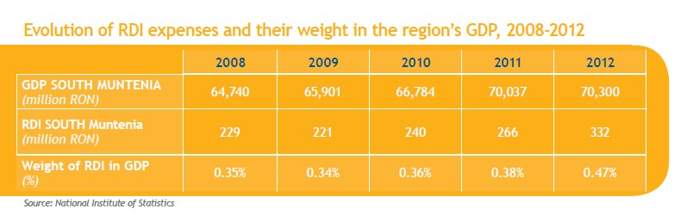

Source: Smart Specialization Strategy of the South Muntenia Region

As of year 2009, the RDI expenses performed in South Muntenia region had an ascending trend. In 2012, they exceeded 332 million RON and 0.47% of the region’s GDP.

Using new technologies to gain access to public services is less important in Romania than in other

European countries. Only 35,5% of citizens were using the Internet in 2013, of which only 21% used it on daily basis.

At the same time, Romania is ranked the 4th worldwide in terms of the quality of electronic communications networks, so it has a network able to support facilities provided by the new technologies.

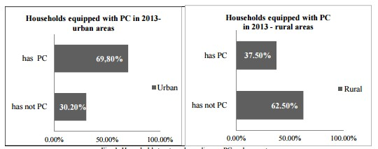

Source: New Trends in Commercial Technologies in Romania: Evolution of Electronic Commerce as Multichannel Retailing Instrument

In 2013, as it is highlighted in the above charts, in South Muntenia region over 69% of people who live in urban area have households equipped with PC and only 37,5% of persons who live in rural area have a personal computer.

Along with the computers usage, in Romania and also in South Muntenia, region it has gained momentum the electronic commerce.

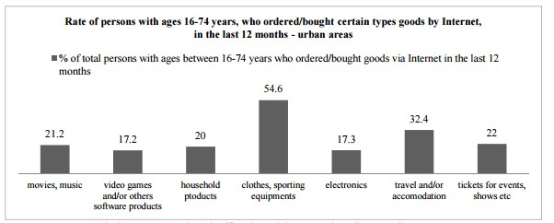

Source: New Trends in Commercial Technologies in Romania: Evolution of Electronic Commerce as Multichannel Retailing Instrument

54,6% from the goods purchased through the internet represents clothes and sporting equipmenty. Other goods bought through e- commerce are travel and/or accomodation services, movies and music and last but not last electronic products.

Moreover, an other exemple of new technology used in South Muntenia region are penetration rate of mobile telephony. The penetration rate of mobile telephony is over 120%, over 14% of the population use Facebook, while 36% have an account in a social network. An interesting element is that not only the youngsters are using these networks, but the group of people aged between 39 and 42 years is very present within these networks.

# PART 1: INNOVATION AND HUMAN RESOURCES (max. 15 pages)

**Introduction: The concept of innovation and its function in business development.**

Innovation represents the implementation of a new or significantly improved product (good or service), or process, a new marketing method, or a new organisational method in business practices, workplace organisation or external relations. The minimum requirement for an innovation is that the product, process, marketing method or organisational method must be new (or significantly improved)to the firm. This includes products, processes and methods that firms are the first to develop and those that have been adopted from other firms or organisations.

Innovation activities also include R&D that is not directly related to the development of a specific innovation. A common feature of an innovation is that it must have been implemented. A new or improved product is implemented when it is introduced on the market. New processes, marketing methods or organisational methods are implemented when they are brought into actual use in the firm’s operations.

Innovation can be defined as the application of new ideas to the prod­ucts, processes, or other aspects of the activities of a firm that lead to increased “value. This “value is defined in a broad way to include higher value added for the firm and also benefits to consumers or other firms. Two of the most important definitions are: product innovation(the introduction of a new product, or a signif­icant qualitative change in an existing product) and process innovation (the introduction of a new process for making or delivering goods and services).

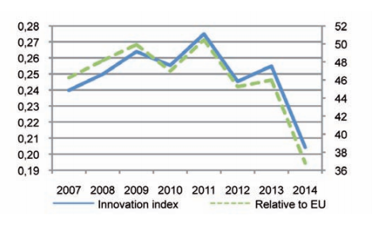In Romania, the promotion of innovation policy has become a priority, after Romania's accession to the European Union. This imposed to the Romanian economy, an accelerated adaptation to the market requirements, including the system of research, development and innovation (RDI).

According to the Innovation Union Scoreboard 2015, Romania is a modest innovator. Innovation performance mostly increased until 2011 after which it has been declining. Innovation performance in 2014 is at a significantly lower level than in 2007.

Romania, as New Member state of European Union, has undertaken a complex process to adapt to new conditions and requirements of European market, especially the growing competition of foreign products and services once the commercial barriers had fallen.

Innovation is recognized as an important contributor to the organizational performance and success. The role of innovations for SMEs has been acknowledged, as surviving by maintaining or increasing market share through innovation is seen as a major issue for all SMEs.

Thus, Romanian SMEs are the one of the most affected area. In order to create a general perspective on small and medium enterprises in Romania, apprehension of the innovative activities developed within these institutions has an essential role. The undertaken research revealed that innovative efforts within SMEs were especially focused on new products, new technologies, new managerial and marketing approaches, renewing the informational system and human resources training. The implementation of these forms of innovations also require changes at the organizational level, technical changes, strategic changes and procedural changes, implying a more complex innovative process at organisational level.

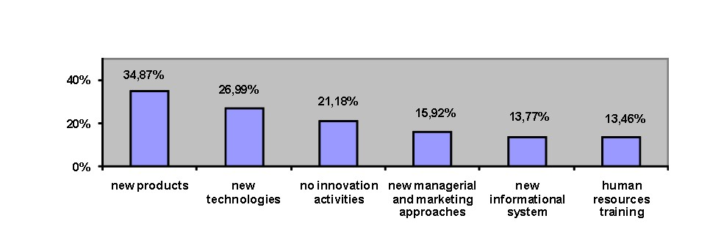

Source: Knwoledge related activities in Romanian SMEs

Analysing innovation activities in Romanian SMEs by size classes, we noticed that the percentages of companies with a view for new products, new technologies, new managerial and marketing approaches, new informational systems and human resources training increase together with the enterprises’ size.

**Innovation activities within SMEs by size classes**

|  |  |  |  |  |
| --- | --- | --- | --- | --- |
| **No.** | **Innovation activities** | **Size classes** | | |
| **Microenterprises** | **Small enterprises** | **Medium enterprises** |
| **1.** | **New products** | **30.75%** | **41.82%** | **44.54%** |
| **2.** | **New technologies** | **20.50%** | **36.36%** | **44.54%** |
| **3.** | **New managerial and marketing approches** | **14.25%** | **18.18%** | **21.85%** |
| **4.** | **New informational systems** | **11.50%** | **17.58%** | **18.49%** |
| **5.** | **Human resouses training** | **11.38%** | **16.97%** | **18.49%** |
| **6.** | **No innovation activities** | **27.13%** | **12.12%** | **5.88%** |

Source: Knwoledge related activities in Romanian SMEs

Analyzing innovative activities within SMEs on fields of activity reveals the following aspects: new products are the most frequently among enterprises within tourism (52.63%), big efforts in order to develop new technologies are undertaken within companies activating in the industrial field (45.33%), the improved managerial/marketing approaches and the human resources training are observed in a higher proportion in constructions (22.58% and 32.26%), the interest for new informational systems is more well-marked in services (17.29%) and the absence of innovation activities is frequently recorded for companies in transportation (26.20%).

**Innovation activities within SMEs by fields of activity**

|  |  |  |  |  |  |  |  |
| --- | --- | --- | --- | --- | --- | --- | --- |
| **No.** | **Innovation activities** | **Fields of activity** | | | | | |
| **Industry** | **Construction** | **Trade** | **Tourism** | **Transportation** | **Services** |
| **1.** | **New products** | **47.56%** | **32.26%** | **31.25%** | **52.63%** | **39.30%** | **24.30%** |
| **2.** | **New technologies** | **45.33%** | **45.16%** | **18.13%** | **34.21%** | **21.12%** | **23.83%** |
| **3.** | **New managerial and marketing approches** | **15.11%** | **22.58%** | **18.13%** | **15.79%** | **11.76%** | **18.69%** |
| **4.** | **New informational systems** | **12.89%** | **12.90%** | **14.38%** | **2.63%** | **11.23%** | **17.29%** |
| **5.** | **Human resouses training** | **12.00%** | **32.26%** | **10.63%** | **23.68%** | **9.89%** | **16.12%** |
| **6.** | **No innovation activities** | **11.11%** | **6.45%** | **24.38%** | **15.79%** | **26.20%** | **22.43%** |

Source: Knwoledge related activities in Romanian SMEs

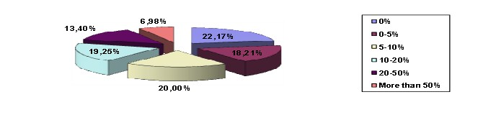The relative low percentage of companies where the absence of innovative approaches was noticed (21.18% in 2013), demonstrating that Romanian entrepreneurs are aware of the fact that as the competition increases within each activity field, innovation represents an efficient method to insure a high competitiveness.

The SMEs dedicated to innovation between 5 -10%, 10-20% and 0-5% of the invested amounts (with weights of 20.00%, 19.25%, respective 18.21%), companies with investments of 20% and 50% (13.40%), and the last position goes to economic agents with investments of more than 50% of the investments fund (with a weight of 6.98% of the SMEs). One can notice that most of the SMEs accomplish– in a higher or lower degree – innovative investments, which actually make the difference between companies, generating competitive advantage.

**SMEs investment in innovation by size classes**

|  |  |  |  |  |
| --- | --- | --- | --- | --- |
| **No.** | **Part of investment dedicated to innovation** | **Size classes** | | |
| **Microenterprises** | **Small enterprises** | **Medium enterprises** |
| **1.** | **0%** | **29.46%** | **10.67%** | **9.17%** |
| **2.** | **0 – 5%** | **19.38%** | **16.33%** | **16.51%** |
| **3.** | **5 – 10%** | **19.22%** | **20.33%** | **24.77%** |
| **4.** | **10 – 20%** | **17.67%** | **21.00%** | **23.85%** |
| **5.** | **20 – 50%** | **8.37%** | **22.67%** | **17.43%** |
| **6.** | **More than 50%** | **5.89%** | **9.00%** | **8.26%** |

Source: Knwoledge related activities in Romanian SMEs

The percentages of SMEs investing in innovation weights from 5 to 10% and 10-20% increase in a direct proportion to the companies’ size, and the proportion of companies that have no innovation activities decreases together with the enhancement of theenterprises, due to the differences regarding the economic potential. As for enterprisesinvesting 20-50% and more than 50% in innovation, the highest weight is covered by small sized enterprises(22.67% and 9.00%) and the lowest by micro enterprises (8.37% and 5.89%).

**SME’s investments in innovation by fields of activity**

|  |  |  |  |  |  |  |  |
| --- | --- | --- | --- | --- | --- | --- | --- |
| **No.** | **Innovation activities** | **Fields of activity** | | | | | |
| **Industry** | **Construction** | **Trade** | **Tourism** | **Transportation** | **Services** |
| **1.** | **0%** | **12.82%** | **17.86%** | **29.32%** | **24.32%** | **25.57%** | **21.79%** |
| **2.** | **0 – 5%** | **15.90%** | **14.29%** | **21.05%** | **16.22%** | **15.86%** | **20.95%** |
| **3.** | **5 – 10%** | **24.62%** | **14.29%** | **21.05%** | **13.51%** | **19.42%** | **18.72%** |
| **4.** | **10 – 20%** | **25.13%** | **21.43%** | **14.29%** | **27.03%** | **18.77%** | **17.32%** |
| **5.** | **20 – 50%** | **13.85%** | **17.86%** | **12.03%** | **8.11%** | **15.21%** | **12.29%** |
| **6.** | **More than 50%** | **7.69%** | **14.29%** | **2.268%** | **10.81%** | **5.18%** | **8.94%** |

Source: Knwoledge related activities in Romanian SMEs

The enterprises that allocated to innovation more than 50% of investments register higher percentage in constructions (14.29%) and lower in trade business (2.26%). Also the enterprises within tourism register a higher percentage regarding the investments in innovation of 10-20% (27.03%) and lower proportions if we take into account investments of 5-10% and 20-50% (13.51%, respective 8.11%).

**Part of SMEs turnover generated by innovation – classification by size classes**

|  |  |  |  |  |
| --- | --- | --- | --- | --- |
| **No.** | **Part of investment dedicated to innovation** | **Size classes** | | |
| **Microenterprises** | **Small enterprises** | **Medium enterprises** |
| **1.** | **0%** | **27.85%** | **10.92%** | **9.52%** |
| **2.** | **0 – 5%** | **19.62%** | **12.97%** | **20.95%** |
| **3.** | **5 – 10%** | **19.30%** | **23.89%** | **27.62%** |
| **4.** | **10 – 20%** | **16.93%** | **23.21%** | **22.86%** |
| **5.** | **20 – 50%** | **11.08%** | **22.18%** | **15.24%** |
| **6.** | **More than 50%** | **5.22%** | **6.83%** | **3.81%** |

Source: Knwoledge related activities in Romanian SMEs

In terms of SMEs size classes, the weight of the firms with no innovation activity increases in an inverse proportion with the SMEs’ size, and the number of enterprises with a 5-10% percentage from their turnover generated by new products/services increases as the size of the firm increases as well. As for the enterprises having 10-20%, 20-50% and more than 50% of their turnover generated by new products/services, the small sized companies hold the highest weights (23.21%, 22.18%, respective 6.83%.

**Part of SMEs turnover generated by innovation – classification by Fields of activity**

|  |  |  |  |  |  |  |  |
| --- | --- | --- | --- | --- | --- | --- | --- |
| **No.** | **Innovation activities** | **Fields of activity** | | | | | |
| **Industry** | **Construction** | **Trade** | **Tourism** | **Transportation** | **Services** |
| **1.** | **0%** | **15.26%** | **10.34%** | **25.58%** | **22.22%** | **23.36%** | **21.84%** |
| **2.** | **0 – 5%** | **18.42%** | **27.59%** | **17.05%** | **5.56%** | **16.45%** | **19.54%** |
| **3.** | **5 – 10%** | **22.11%** | **13.79%** | **18.60%** | **16.67%** | **22.04%** | **22.99%** |
| **4.** | **10 – 20%** | **23.68%** | **13.79%** | **20.93%** | **19.44%** | **21.05%** | **15.23%** |
| **5.** | **20 – 50%** | **15.26%** | **31.03%** | **11.63%** | **25.00%** | **12.83%** | **14.37%** |
| **6.** | **More than 50%** | **5.26%** | **3.45%** | **6.20%** | **11.11%** | **4.28%** | **6.03%** |

Source: Knwoledge related activities in Romanian SMEs

The analysis of the SMEs by fields of activity highlights the following aspects: as for the enterprises with no innovation activities the highest weight is registered in trade business (25.58%) and the lowest one in constructions (10.34%). If we consider the firms having more than 50% of their turnover generated by new products/services the highest percentage is recorded by the companies in tourism (11.11%), and the lowest one among those in constructions (3.45%). The economic agents operating in construction also hold the highest weight of firms with 0-5% and 20-50% (27.29%, respective 31.03%) of their turnover generated by new products/services.

**Used IT components within SMEs**

**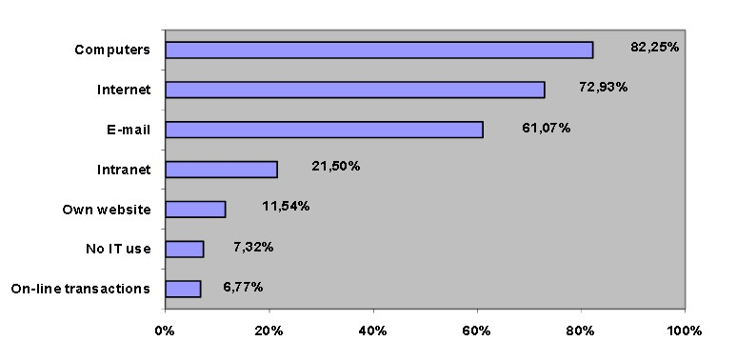**

Source: Knwoledge related activities in Romanian SMEs

82.25% of Romanian SMEs possess computers, 72.93% of the SMEs have access to the Internet, 61.07% use the e-mail, 21.50% have Intranet, 11.54% have their own website and 6.77% operate on-line transactions.We also have to point out the fact that 7.32% of the SMEs do not use the information technology at all. The outcome of this research underlines the efforts for computerization activities within Romanian SMEs and their compliance with the European standards.

**Used IT components within SMEs by size classes**

|  |  |  |  |  |
| --- | --- | --- | --- | --- |
| **No.** | **Used IT components within SMEs by size classes** | **Size classes** | | |
| **Microenterprises** | **Small enterprises** | **Medium enterprises** |
| **1.** | **Computers** | **78.25%** | **89.39%** | **89.92%** |
| **2.** | **Email** | **52.63%** | **72.42%** | **85.71%** |
| **3.** | **Internet** | **67.00%** | **81.52%** | **89.08%** |
| **4.** | **Intranet** | **12.50%** | **32.12%** | **52.10%** |
| **5.** | **Firm’s own web site** | **9.88%** | **14.24%** | **15.97%** |
| **6.** | **On-line transaction** | **3.75%** | **11.21%** | **15.13%** |
| **7.** | **No IT components are used** | **10.25%** | **2.73** | **0.84%** |

Source: Knwoledge related activities in Romanian SMEs

In the above table it can be noticed that the percentage of companies using computers, e-mail, Internet and Intranet, have their own site and use sales/ shopping on-line increases proportionally with the companies’ size and the percentage of enterprises that do not use computerized technology increases with the decrease of companies. This situation is normal, considering that when SMEs increase, their economic potential increases, determining the growth of capacity but also of necessity to use certain IT components.

**Used IT components within SMEs by field of activity**

|  |  |  |  |  |  |  |  |
| --- | --- | --- | --- | --- | --- | --- | --- |
| **No.** | **Innovation activities** | **Fields of activity** | | | | | |
| **Industry** | **Construction** | **Trade** | **Tourism** | **Transportation** | **Services** |
| **1.** | **Computers** | **86.67%** | **90.32%** | **77.50%** | **92.11%** | **77.27%** | **84.58%** |
| **2.** | **Email** | **72.00%** | **80.65%** | **55.00%** | **60.53%** | **49.20%** | **66.59%** |
| **3.** | **Internet** | **80.89%** | **90.32%** | **65.63%** | **78.95%** | **60.70%** | **80.37%** |
| **4.** | **Intranet** | **27.56%** | **29.03%** | **18.13%** | **34.21%** | **13.64%** | **24.77%** |
| **5.** | **Firm’s own web site** | **12.00%** | **0.00%** | **6.25%** | **15.79%** | **8.29%** | **16.59%** |
| **6.** | **On-line transaction** | **10.22%** | **12.90%** | **5.00%** | **0.00%** | **5.08%** | **7.24%** |
| **7.** | **No IT components are used** | **2.67%** | **3.23%** | **6.25%** | **5.26%** | **11.50%** | **7.01%** |

Source: Knwoledge related activities in Romanian SMEs

SMEs within transportation register the lowest percentage of enterprises equipped with computers (77.27%), that use e-mail, Internet and Intranet (49.20%, 60.70%, respective 13.64%), and hold also the highest weight of companies that do not use IT components (11.50%). Also, the enterprises in the constructions field hold higher percentages of companies having access to e-mail and internet services (80.65. respective 90.32%), making on-line transactions (12.90%) and surprisingly this field has no record of firms having their own website. In the tourism sector the most numerous firms equipped with computers (92.11%) and Intranet (34.21%), but there are no organizations using the on-line transactions and enterprises from the industrial field register the lowest weight of firms that do not use IT components (2.67%).

**The purpose of using Internet by SMEs**

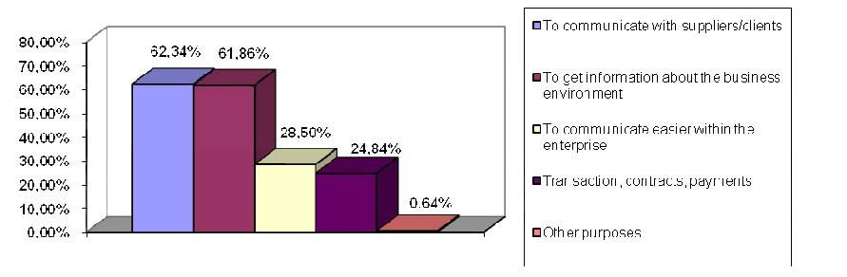

Source: Knwoledge related activities in Romanian SMEs

In term of Internet/Intranet used in SMEs, 62.34% of the entrepreneurs communicate with suppliers/clients, 61.86% of the entrepreneurs are looking to get information regarding the business environment, 28.50% use Internet/Intranet to communicate easier within the enterprise, while 24.84% use these IT components for transactions, contracts and payments.

In what is concerning solutions which sustain the activity of the SME sector, which is without a doubt the most important sector in the Romanian economy, but is never considered as such are: defrosting crediting for financing SME’s, a large number of fiscal facilities meant to ease up the financial situation of SME’s, decreasing social contribution percentage, facilitating crediting, guaranteed by the state, freezing salaries in all public and private sector.

Some measures that entrepreneurs are taking to maintain their activities are related to reduce the administrative expenses (36%), the number of employs (19%) and the incomes of the employs (9%).In the actual situation SME’s contribute to the GDP is approximately 70% considering that 600.00 SME’s exist in Romania in the beginning of 2010. Recording to our study 30% of the actual SME’s could go bankrupt due to the actual financial crisis. The difficult situation, that Romanian economy is facing, lead to an alarming increase of bankruptcy among SME’s..

**Innovation in the enterprise**

Based on the surveys realized with the representative stakeholders about the level of the innovation of SMEs and the relationship between them and Public Administration and R&D environment, South Muntenia Regional Development Agency concluded the following information:

Most of the relevant stakeholders agreed that Innovation represents introduction of new product/services on the market (43.48% of SME, 30.44% of Public Administration and 26.09 of R&D environment). While 44.45% of the representatives of Public Administration claimed that innovation means to enhance existing product/services, only 21.43 of the respondents of SMEs think that new marketing techniques represent an innovation. Approximately 73% of R&D environment consider that innovation aims to enhance an existing product/services, to implement a new process of innovation, to use mew marketing techniques and new organizational methods meanwhile only 27,28% consider that innovation means to introduce a new product/services on the market.

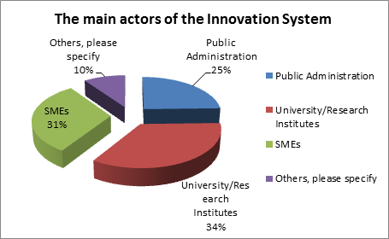

In the opinion of the respondents the main actors of the Innovation System from South Muntenia region are R&D environment (34%) and SMEs (31%). Only 25% of the organization from Public Administration are considered to be important in the development of innovation in the region.

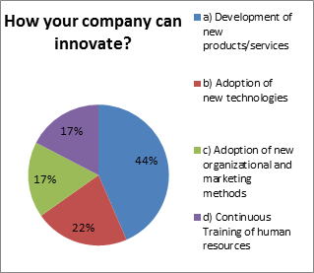As an actor involved in the innovation process, over 44% of the representatives of SMEs agreed that their company can innovate by development of new products/services, 39% of them thought that innovation consists in the adoption of new technologies and new organizational and marketing methods and only 17% of the respondents claimed that continuous training of human resources is one of the most important activity in the innovation process.

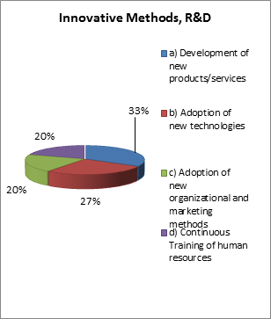 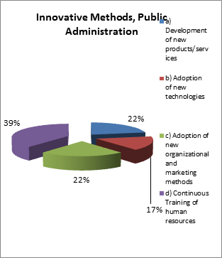

Meanwhile 39% of Public Administration used as innovative methods the development of new products/services, only 20% of R&D environment found this methods advisable. A fifth of these relevant actors claimed that they had used new organizational and marketing methods. New technologies and continuous training methods are also 2 innovative methods used by respondent in the development of their company’s activity.

In what is concerning the relationship between stakeholders, the most representative of SMEs stated that they have no relationship with Public Administration and R&D environment. However, a small proportion of SMEs from South Muntenia region has a codependent relationship with the representatives of the City Hall. They cooperated with them in writing project grants (consultancy firms) or in setting the tariffs for the local public transport (the representatives of the City Hall approved the price for travel tickets). In addition, in the South Muntenia region, there are companies that have signed service agreements with municipalities (physical and electronic archiving).

Although, a large part of the business environment claimed that they have no collaboration or cooperation relationship with Public Administration, its representative argued that business environment activity is supported by legal means as: organization of information session regarding the funding opportunities for SMEs, facilitate the link between different companies with similar profile or by concluding service agreement with various firms which activities folds on the needs of public administration.

R&D environment argued that their institutions collaborate with different SMEs, universities and research institutes which support innovative entrepreneurship, adoption of new technologies or innovation in human resources.

The future projects that stakeholders intend to develop in the South Muntenia region, aim to develop the region economically.

In terms of SMEs, it is required to endow the companies with new competitive equipments to enhance the quality of products and to reduce the manufacturing costs, to improve the SMEs turnover through the utilization of innovative products and to train the staff regularly. In the same time, Public Administration intends to be involved in many European projects and to implement the new provision of national and European legislation. Moreover, it was considered a necessity to include the software services for Public Administration to provide qualitative public services and facilitate the access to public services, to eliminate the need of taxpayers’ movement to public administration offices and to increase the participation and involvement of citizens in the governance process. Also, one of the most important project is to qualify and train the staff to provide qualitative services for the citizens. The future R&D projects are industry-specific, and there are focused on the development and implementation of innovation for customer satisfaction.

In the South Muntenia region, 40% of the SMEs respondents considered that the use of technological activities are the easiest way to innovate, followed closely by scientific (27%) and commercial activities (27%). It can be noticed that no firm from the region had developed up to this point of time scientific activities.

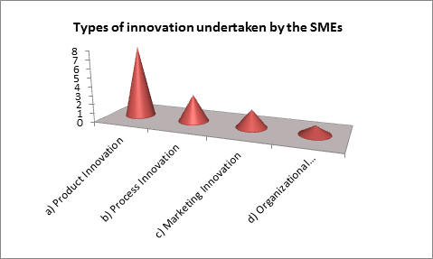

Over 57% of the surveyed people stated that their company can innovate using product innovation. A small part of them supported that a company from South Muntenia region can innovate using process innovation, marketing innovation or organizational innovation. Moreover, 45% of SMEs develops its activity using new technologies (60%).

Although, 45% of the representative of SMEs considered that the adoption of new technologies is useful for their organization, only 60% of them affirmed that the utilization rate of new technologies in their organization is between 0 – 30%.

To improve the manufacturing activity and the turnover of the companies, the entrepreneurs used as new technologies the competitive equipment like: performance machines in preparation, treatment and seeding agricultural crops, equipment for the production of dough shape for various kinds of dishes (éclair), cars for food transport refrigeration or newest cars with improved equipments in the fleet. Also, the new technologies used in the organization and management of these companies are: internet and email, new programs and software which help the entrepreneurs to carry out and manage the company’s activities, English and communication training courses for the staff who operate with the audience and also, training courses for human resources involved in the manufacturing process.

The main challenges which the representative of SMEs faced in a bid to offer to the customer innovative products and services were the challenges in the sphere of knowledge and the increase of the requirements regarding the company's competitiveness on the market. Also, establishing the training needs and identifying training providers to offer adequate training courses for employers, and the high costs incurred by the introduction of new product/services on the market, by acquisition of the necessary equipments and by continuous training for human resources represent a major problem for the entrepreneurs. The high salaries for skilled labor force for which the company cannot support them is another challenge which the representative of SMEs faced more and more often.

In what is concerning the solutions which can improve the activity of the SME sector, which is without a doubt the most important sector in the Romanian economy, are: defrosting crediting for financing SME’s, facilitating crediting, guaranteed by the state, creating facilities and new grant programs which support the entrepreneurs who employ skilled people and offer to their employees the opportunity to participate in periodic training courses.

**Human Resourses**

In the last years, the interest in the human resource management field has been obvious. This tendency is also valuable in Romania. We can see improvements in human resource management research and also in practice. The Romanian companies also understood that the human resources are their main strategic resource and must be managed as an investment and not only as a cost. There are two directions in which the Romanian companies take actions: the main methods Romanian organisations attract and maintain their employees are the rising of the motivational level between the employees, assuring appropriate working conditions, teamwork and professional and personal development, talent management. In the same time, the companies emphasise the necessity of a high level of qualification of the human resources specialists in order to apply the principles of human resource management inside their organisations.

The human resources department is one of the most important organisational subdivisions in Romania. 52.63% of the investigated SMEs have a separate human resources department while 47.37% don’t organise their human resources activity inside a separate department. In small and medium size organisations the human resources strategies don’t have a structured nature.

It is known that the role of human capital in the global strategy of the organization is very important if we refer to the staff that focuses on the development and implementation of knowledge which can increase the turnover of the company or at least can make a difference.

In the opinion of the representative of SMEs from South Muntenia region, the sort of innovation for human resources which their company should focused is to improve periodically the performance of their employees through training and refresher courses needed to use the new technological equipments, trainings and business seminars.

The main challenges that the entrepreneurs faced when their company tried to innovate in the human resources field were the changes made in the manufacturing process due to the acquisition of the new machinery from the external partners and the reluctance of their employees in the utilization of these new equipments. The problem was solved through the qualification of the personnel to use the concerned equipments. Others, challenges encountered by the representatives of SMEs were the lack of funds and qualified personnel, lack of seriousness of the employers, the desire to earn money without developing a qualitative job activity. Also, the senior employees make the learning and adaptation process to be unwieldy. Moreover, the employments tended to become taboo if we refer to the comparative qualifications versus the amount requested.

In order to facilitate the innovation in human resources field, it should be improved the mobility and flexibility of the organization in recruiting human resources and the development of the communication skills of the staff. Also, the changes that represent real problems in the SMEs activities are: high taxes to collect the information necessary for the development of the company activity (for e.g. high taxes to obtain the necessary information to prepare the application form, expensive price for employers training courses), the improvement of the employees awareness to attend regular the training courses (their reluctance to accept the slogan “you can always learn new things), in order to offer to the customers the innovative products/services, to deal with the changing business environment (for e.g.: to speak fluently English) and to help the company to grew on the marketplace.

**New orientations in Human Resources IN THE LAST YEARS AND FOR THE FUTURE (TENDENCIES)**

It is known that human resource management is the process of employing people, training them, compensating them, developing policies relating to them and developing strategies to retain them. Also, HRM has undergone many changes over the last twenty years, giving it an even more important role in today’s organizations. It suggests to the management team how to strategically manage people as business resources in order to develop a competitive advantage, which involves building the capacity of the company to offer a unique set of goods or services to its customers. To build the an effective human resources, private companies compete with each other in a "war for talent." It's not just about hiring talent; this game is about keeping people and helping them grow and stay committed over the long term.

Knowledge management became without any doubt, one of the most interesting research topics in the last couple of years. It is the art of creating value by using organizational intellectual capital, which is what the organization knows. Knowledge management is a conscious effort to get the right knowledge to the right people at the right time so that it can be shared and put into action. In the contemporary business environment, the competitive position of companies among others is influenced by its capability to create new knowledge which in return results in the creation of a competitive advantage. Organizational learning is an integrative characteristic of most companies although not all of them are able to utilize it for the creation of an improved performance. Organizational knowledge and knowledge management and interconnected and both are widely dependent on human resources.

To innovate, firms should constituted a ‘knowledge-capital’, defined as a set of information and knowledge produced, acquired and used in the value creation process. In a context of global competition, the development of a firm's knowledge-capital mostly relies on the cooperation that the firm may establish with other large and small companies and/or with other organizations like institutions of academic research and institutions supporting innovation. Knowledge-capital refers to the accumulated knowledge of one or several linked firms (embedded in the individuals - know-how - machines, technologies and routines of the enterprise), which is continuously enriched by information flows and which is used in the production process or more globally in the value creation process. Thus, it is a dynamic concept - a process - that defines the knowledge accumulated by one or several firms, continuously enriched and combined in different ways and eventually used or commercialized. This productive aim - the creation of value - is the main characteristic, which turns knowledge into ‘capital’.

Due to fewer human and financial resources, small and medium-sized companies, usually record weak performances in terms of research and innovation. However, innovation has nowadays become a competitive stake, and both SMEs' place in the productive system of economies and their role in economic growth and innovation. While the ability of SMEs to build a strong knowledge-capital remains weak (mainly due to fewer resources), SMEs play an important role in the continuous enrichment of larger companies' ones. At the same time, their strength within larger firms' innovation networks largely depends on their ability to develop and reinforce their own knowledge-capital.

Also, the absorptive capacity is a central component in the understanding of knowledge-capital formation, being a prerequisite for its formation. Absorptive capacity was firstly defined as the ability of a firm to recognize the value of new, external information, assimilate it and apply it to commercial ends. After, the concept was redefined through the distinction between a potential absorptive capacity and a realized absorptive capacity. Also, it was identified four dimensions: acquire, assimilate, transform and exploit. It is considered as an essential capacity to build competitive advantages over competitors in a context of growing open innovation. In an open innovation process, a firm builds up its knowledge-capital through dynamic knowledge management of its ‘knowledge capacities’ which was defined as a firm's critical capabilities of managing internal and external knowledge: inventive, absorptive, transformative, connective, innovative and desorptive capacities. These six capacities are linked through three knowledge processes - knowledge exploration, retention and exploitation - performed either internally or externally. The combination of these capacities used by firms can explain their difference in knowledge trajectories, alliance strategies, organizational configurations and innovation performance.

Management by values (MBV), another relevant component of human resourses department, ​​creates the framework for today's leaders and managers. MBV method is important in the management of organizations in a complex environment. The issue of company values was ​​previously considered too soft to be turned into a serious approach to management, now it turned into a central part in discussions about strategy and [organizational changes](https://ceopedia.org/index.php/Organizational_change). Focusing on the core values (key, most important values), it ​​has become necessary to carry out organizational change.

The values ​​should be the focus on issues related to organizational change, as well as in the whole practice of management. In some of the world's emerging economies, management by values is quickly becoming a major force for the rebuilding of sustainable and competitive culture.

Corporate Social Responsibility is the continuing commitment by business to behave ethically and contribute to economic development while improving the quality of life of the workforce and their families as well as of the local community and society at large. Thus, the business organizations have waked up to the need for being committed towards Corporate Social Responsibility because they have realized the importance of HR function in the organizational culture is immense. An organization can exhibit a better image in the minds of people by presenting itself as an excellent employer which cares for its people and involves them in the ambit of social responsibility. This involvement of employees indicates the strategic importance of HRM in the CSR initiatives of an organization. Human Resource policies, forming the framework for the culture in the business management, create awareness towards the need to achieve the business goals in the best possible and ethical manner.

In SMEs there is a large need to confront with broadly-understood Corporate Social Responsibility (CSR) and educate owners and managers in this respect. Individual elements of social responsibility are already addressed in the case of various further educational courses. However, a comprehensive further education and consulting programme is non-existent. Research and teaching have been intensively involved in the CSR in large corporations. There is a deficiency of SME-specific concepts concerning the perception of social responsibility.

Also, SMEs are heterogeneous in size, resources, management style and personal relationships which make it difficult for them to adopt large firm practices. A key difference between large and small firms is that in small firms, ownership and management are not separated to the same extent as they are in large multinational firms. Control remains in the hands of the owners, potentially enabling them to make personal choices about the allocation of resources. The relationship with the local authorities is far closer and more direct than that of large business.

In general the management of CSR in SMEs is described as an ad hoc issue, e.g., ‘someone rings up and asks us for something’. In an empirical study of Romania, no SMEs had a person appointed to manage CSR. The responsibility of CSR in SMEs tended to rest with the owner/manager or another senior manager of the firm.

Considering that SMEs tend to mention the community as an important stakeholder when defining CSR, it is not surprising that they describe their CSR activities along the lines of community projects and environmental initiatives. Common activities included working free of charge for charities, making charitable donations and recycling initiatives. On the other hand, an analysis showed that SME managers clearly have an inside-out approach to CSR, with a strong emphasis on the internal (corporate culture) dimension. When the SME managers talk about CSR, the rhetorical articulation of CSR seems to demonstrate that the SMEs are truly concerned with their employees, and the relationship between managers and employees seems to be of a personal nature. The managers know all employees by name, and the way they talk about their work functions and personal characteristics resembles the way one talks about family members or friends. When the SME managers talk about strategic planning and CSR communication, the SME managers’ statements truly demonstrate that an integrated approach to CSR communication as a part of the overall business strategy is non-existent. SMEs may or may not have written strategic documents, but they do not use them as a guideline for practice in their daily operations. A formal and planned approach to communication is not particularly valued. When communicating internally, managers prefer oral one to one dialogue to computer-mediated communication . To conduct CSR activities, SMEs often maintain the buy-in of their employees while simultaneously develop greater focus on sales growth, profitability and competitive edge.

In Romania, the INMA agents have actually knowledge of:

|  |  |  |
| --- | --- | --- |
| **NEW ORIENTATION** | **USE IN SMEs** | **IMPORTANCE FOR SMEs** |
| Knowledge Management | X | 5 |
| Generation and enhancement of knowledge | X | 4 |
| Competence-based management | X | 5 |
| Lifelong learning | X | 5 |
| Organizational learning | X | 4 |
| Knowledge capital | X | 5 |
| Absorptive capacity | X | 4 |
| Management by Value | X | 5 |
| Corporate Social Responsibility | X | 5 |

Also, the entrepreneurs consider that these new orientation are very important in the development of new competitive products and/or services.

# PART 2: NEW TECHNOLOGIES used in general in smes related to the profile (max. 5 pages)

The New Technologies which are used by SMEs in the South Muntenia region are described in the table below:

|  |  |  |  |
| --- | --- | --- | --- |
| **NAME OF NEW TECHN.** | **DESCRIPTION** | **DEPARTMENT USING IT** | **RATE OF IMPORTANCE** |
| E-mail | System for sending and receiving messages electronically over an internet computer network | Global environment of the enterprise | 5 |
| Telephony | Integrated system used by all employees | Global environment of the enterprise | 5 |
| Information & Communication | Cloud storage system to easy chech the information | Global environment of the enterprise | 5 |
| Site | Presentation of the products/services offered by SMEs | Organizational Management | 5 |
| Microsoft Office | Software for editing and processing data | Global environment of the enterprise | 5 |
| B.D.D system | System for managing electronic documents | Management Strategy | 5 |
| Saga software | Accounting Programe | Economic and Financial Management | 5 |
| Revisal software | Employees Administration Programe | Human Resources | 5 |
| Electronic invoicing system | System for issuing the invoices in the electronic format | Economic and Financial Management | 5 |
| Multifunctional equipments | Agricultural equipment which performs multiple operations at the same time | Production | 5 |
| cars for food transport refrigeration | Product transportation in optimal conditions | New Tehnologies | 5 |
| New competitive equipments | New equipments which improve the manufacturing process and the quality of the products/services | Production | 5 |
| Tachograph | It counts the number of kilometers of a driver in a car | Management Strategy | 5 |
| Cartons | Compaction of the products in order to facilitate the storage and transport of the products | Suppliers’ Management | 5 |

# PART 3: CONCLUSSIONS (max. 5 pages)

**Resume of situation of SMEs with respect to previous points analyzed under innovation and new technologies**

It is known that Romania is a modest innovator which has undertaken a complex process to adapt to the new conditions and requirements of European market, especially the growing competition of foreign products and services once the commercial barriers had fallen. Because innovation is recognized as an important contributor to the organizational performance and success, the SMEs innovative efforts were especially focused on new products, new technologies, new managerial and marketing approaches, renewing the informational system and human resources training. The implementation of these forms of innovations also require changes at the organizational level, technical changes, strategic changes and procedural changes, implying a more complex innovative process at organisational level.

Analysing innovation activities in Romanian SMEs, we noticed that the percentages of companies with a view for new products, new technologies, new managerial and marketing approaches, new informational systems and human resources training increase together with the enterprises’ size. In a direct proportion with the companies’ size, increased also, the percentages of SMEs which invested in innovation from 5 to 10% and from 10 to 20%.

Moreover, SMEs from the construction area allocated to innovation more than 50% of its Investments, companies from tourism developed the newest competitive products while the organizations from industrial field made big efforts in order to develop new technologies. In addition, 82.25% of Romanian SMEs possess computers, 72.93% of the SMEs have access to the Internet, 61.07% use the e-mail, 21.50% have Intranet, 11.54% have their own website and 6.77% operate on-line transactions.

Most of the relevant stakeholders agreed that Innovation represents introduction of new products/services on the market while 44.45% of the representatives of Public Administration claimed that innovation means to enhance the existing products/services. Only 27,28% of R&D environment consider that innovation is the introduction of new products/services on the market. In terms of SMEs, it is required to equip the companies with new competitive equipments, to improve the SMEs turnover through the utilization of innovative products and to train their staff regularly. In the same time, Public Administration intends to include the software services to provide qualitative public services for citizens and facilitate the access to public services.

The main relevant actors of the Innovation System from South Muntenia region are R&D and business environments. Although, a large part of the business environment claimed that they have no collaboration or cooperation relationships with Public Administration, its representative argued that business environment activity is supported by the City Hall of the town. Moreover, R&D environment argued that their institutions collaborate with different SMEs, universities and research institutes which support innovative entrepreneurship, adoption of new technologies or innovation in human resources.

In what is concerning the main challenges that the entrepreneurs faced when their company innovated in the human resources field were the changes made in the manufacturing process due to the acquisition of the new machinery from the external partners and the reluctance of their employees in the utilization of these new equipments, the lack of funds and qualified personnel, lack of seriousness of the employers and their desire to earn money without developing a qualitative job activity.

In order to facilitate the innovation in human resources field, it should be improved the mobility and flexibility of the organization in recruiting human resources and the development of the communication skills of the staff. Also, it should be created european programmes which support the business environment by incurring a part of the fiscal expenditure and the costs for specialized training courses for employeers and for the aquisition of the competitive equipments for SMEs.

**Main conclusions and recommendations**

The profile of Innovation Management Agent in SMEs represents one of the most relevant actor which can improved the SMEs competitiveness through innovation, while promoting the development of organization strategy. Thus, it should be enhanced in terms of the business goals, the relationship with other people, the structure of the organization and management policies because the era of globalization has forced the SMEs entrepreneurs to face massive changes regarding how they operate their businesses. The challenges have also impelled entrepreneurs to craft and execute strategies relevant to the new episode of intense competition.

The analysis of current situation showed that today, the representative of SMEs have no professional competences and standards about how to be able to face and answer to different situation and changes, how to implement the procedure that are established and how to maintain a continuous updating training in the area of New Technologies, Strategic Management, Knowledge Management, Corporate Social Responsibility and People Management.

In order to support the business environment represented by small and medium enterprises, the INMA profile aims to develop an innovation culture in the firm‘activities which implies the reorganization of work in the institution, adaptation of human resources knowledge to the new level of competition and the inclusion of new technologies in the strategy competitiveness.

In what is concerning the knowledge areas that INMA profile was focused, it was presented the main information that SMEs entrepreneurs need to learn how to be efficient in the business environment where they develop the firm’activities. Wide knowledge about enterprise organization, generic know-how about different technologies, change management, knowledge management, information and communication technologies, human capital management, new product development and marketing and commercial management are the fields without a highly specialized entrepreneur cannot understood the competitive advantage of managing a business.

To develop an “Innovation culture” into the SMEs, it means a better organizational efficacy and the adequancy of human resources to the new standars of competition and also the introduction of the new technological improvements in the company manufacturing. All the 5 modules of the IMNA profile support the SMEs environment to acquire the necessary information which can develop a competitive and profitable business.

“The configuration of new organizational framework in the enterprises that eases the adoption of innovative policies” is a module which helps the representatives of companies to understand the firm as an open system whose efficiency will depend on the interaction between stakeholders. Moreover, the module will provide to the entrepreneurs the opportunity to learn how to develop a management system based on the enterprises processes which facilitate the SMEs internal coordination, how to take efficient the decisions in order to manage the existing knowledge and technology in the enterprise, how to develop the innovation projects in the company field of activity and how to promote the active participation of the emplyeers in the innovation project.

Throught the next module the representatives of business environment, find out how to adequate a human resourses to this new way of understanding the enterprise reality based on change and innovation. Moreover, the IMNA profile train them to organize and manage the information and the documentation used by the organization, to analyze the fesability of an innovation project according with the opportunity criteria available in the market, to maximize the organizational efficacy and efficiency process, to manage in a efficient way the intelectual capital of the enterprise through the improvement of people talent, to develop a corporate communication strategy aligned to the company strategy, to favor an enterprise culture that promotes learning and innovation at all levels and to strengthen the enterprise productivity promoting motivation and integration of human element in the goal of the organization.

“To implant management system in the enterprise based on the creation value, ethics and corporate responsability”, SMEs entrepreneurs should developed Corporate Social Responsability practices as a strategic advantage which creates added value for their organization and an enterprise management system based on value management. Also, they should introduced new ethical principles in the design of the management system which exist in their company.

The last module highlights the importance of using the new technologies in the all company’s departments by promoting the internet and ICT application, by disseminating the innovation process, technologies and methods which are implemented in the organization and by applying the new technologies in the human resources field and e-commerce.

In conclusion, in order to implement the information described by the profie ”Innovation Management Agents in SMEs”, the entrepreneurs should understand how can support the business strategy. Also, they should known the philosophy related to the employment of the personal, the employment package that can entice superior employees and the steps for hiring process that follows the national legisation about employment on the labour market. Moreover, the SMEs representatives need advanced equipments, new technologies as: services, software, communication devices and databased. They need also, open minded employeers who embody with the company’s values, work hard and smart, have the specific skills required, learn quickly when new skills are needed, are able to work with little supervision, take initiative to make things happen, are comfortable in the uncertainty of an entrepreneurial situation, are flexible to business needs and changing requirements.

# Bibliography

**PUBLICATIONS**

**STATISTICAL PUBLICATIONS**

* NATIONAL BANK OF ROMANIA, “Foreign Direct Investment in Romania, editions 2005-2012, <http://www.bnro.ro/SearchResult.aspx>.
* NATIONAL INSTITUTE OF STATISTICS , “Research – Development inRomania during the period 2005 – 2010, collection of statistical datas, [www.insse.ro](http://www.insse.ro).
* NATIONAL INSTITUTE OF STATISTICS, Tempo Online Database, <https://statistici.insse.ro/shop/>.
* NATIONAL INSTITUTE OF STATISTICS, “Innovation in industry and services during the perioad 2008-2010, Teritorial Statistics 2012, [www.insse.ro](http://www.insse.ro)
* NATIONAL INSTITUTE OF STATISTICS, “New enterprises and entrepreneurs in the Romanian Profile , 2013, [www.insse.ro](http://www.insse.ro).
* POST-PRIVATIZATION FOUNDATION, “Curent status of the Romanian SMEs, 2012, <http://www.postprivatizare.ro/romana/wp-content/uploads/2012/06/studiu-IMM_2012.pdf>.
* POST-PRIVATIZATION FOUNDATION, “Annual Report regarding the SMEs sector from Romania, february 2011.

**ONLINE PUBLICATIONS**

* ANNALES UNIVERSITATIS APULENSIS SERIES OECONOMICA- “The impact of global crisis on romania’s economic development“

<http://journals.indexcopernicus.com/issue.php?id=462&id_issue=846369>

* BUSINESS PERSPECTIVES - “Corporate social responsibility and SMEs: a literature review and genda for future research “

<http://businessperspectives.org/journals_free/ppm/2011/PPM_2011_04_Vo.pdf>

* DELOITTE - “Global Human Capital Trends 2015“

<http://www2.deloitte.com/us/en/pages/human-capital/articles/introduction-human-capital-trends.html>

* DELOITTE - “Leading in the new world of work“

<https://www2.deloitte.com/content/dam/Deloitte/global/Documents/HumanCapital/gx-cons-human-capital-leading-in-the-new-world-of-work.pdf>

* EUROPEAN COMMISSION - “Country Report Romania 2015 Including an In-Depth Review on the prevention and correction of macroeconomic imbalances“ <http://ec.europa.eu/europe2020/pdf/csr2015/cr2015_romania_en.pdf>
* EUROPEAN COMMISSION - Innovation Union Scoreboard

<http://ec.europa.eu/growth/industry/innovation/facts-figures/scoreboards/files/ius-2015_en.pdf>

* EUROPEAN ECONOMY, “Macroeconomic imbalances Country Report – Romania 2015“
* <http://ec.europa.eu/economy_finance/publications/occasional_paper/2015/pdf/ocp223_en.pdf>
* RJRS - “Territorial discrepancies concerning SMEs performances in Romania <http://www.rrsa.ro/rjrs/N2-ISAIC.PDF>
* OECD - “Oslo Manual: Guidelines for Collecting and Interpreting Innovation Data“, 3rd Edition, 2005

<http://www.oecd.org/sti/inno/oslomanualguidelinesforcollectingandinterpretinginnovationdata3rdedition.htm>

* PROQUEST - Knwoledge related activities in Romanian SMEs

<http://search.proquest.com/openview/f7211d57e14699bf127fad1870fb3e57/1?pq-origsite=gscholar&cbl=276234>

* ROMANIA INSIDER - Foreign direct investment, up in Romania in the first five months <http://www.romania-insider.com/foreign-direct-investment-up-romania-first-five-months/152822/>
* SCIENCEDIRECT, “New Trends in Commercial Technologies in Romania: Evolution of Electronic Commerce as Multichannel Retailing Instrumen“

<http://www.sciencedirect.com/science/article/pii/S2212567115010060>

* SIOP - Work in the 21st Century: The Changing Role of Human Resources
* SOUTH MUNTENIA REGIONAL DEVELOPMENT AGENCY, Smart Specialization Strategy of South Muntenia Region
* TRADIND ECONOMICS Romanian Empoyment Rate

<http://www.tradingeconomics.com/romania/employment-rate>

* TIBICUS UNIVERSITY - The importance of sme’s in romania, in the context of the global crisis <http://fse.tibiscus.ro/anale/Lucrari2011/069.pdf>
* UNPAN - “Governmental Strategies for using new technologies to deliver more efficient public services - Romania’s case“

“<http://unpan1.un.org/intradoc/groups/public/documents/undpadm/unpan046720.pdf>

* WORLD BUSINESS COUNCIL FOR SUSTAINABLE DEVELOPMENT, Corporate Social Responsability :Making good business sens, January 2000

<http://www.wbcsd.org/web/publications/csr2000.pdf>

**SITES**

* ACTMEDIA - “Romania, Strongth growth ahead amid fiscal loosening and financial“

<http://actmedia.eu/daily/romania-strong-growth-ahead-amid-fiscal-loosening-and-financial-risks/62155>

* INVESTOPEDIA - “What is Human Resources“

<http://www.investopedia.com/terms/h/humanresources.asp>

* SAYCO - Corporate social responsibility: the key role of human resource management

<http://www.saycocorporativo.com/saycouk/bij/journal/vol2no1/article9.pdf>

* ToKnowPress- Human resources and Knowledge management

<http://www.toknowpress.net/ISBN/978-961-6914-02-4/papers/ML13-356.pdf>

* ToKnowPress-Human resources and Knowledge management

<http://www.toknowpress.net/ISBN/978-961-6914-02-4/papers/ML13-356.pdf>

* MALLER BAKER - Definition of corporate social responsability

<http://mallenbaker.net/article/clear-reflection/definitions-of-corporate-social-responsibility-what-is-csr>